H.T No
Regulations:
A18

Sreenidhi Institute of Science and Technology
(An Autonomous Institution)
Code No: 7A201 Date: 23-Aug-2023 (FN)

B.Tech I-Year II- Semester External Examination, Aug/Sept-2023 (Supplementary)
ELECTRICAL CIRCUITS AND NETWORKS-I (EEE)

Time: 3 Hours Max.Marks:70

Note: a) No additional answer sheets will be provided.
b) All sub-parts of a question must be answered at one place only, otherwise it will not be valued.
c) Missing data can be assumed suitably.
Bloom's Cognitive Levels of Learning (BCLL)

Remember | L1 | Apply | L3 | Evaluate | L5
Understand | L2 | Analyze | L4 | Create | L6

Part - A Max.Marks:20

Answer all QUESTIONS.

 |  | BCLL | CO(s) | Marks
1 | Write the statements of Kirchoff’s voltage and current laws. | L1 | CO1 | [2M]
2 | Draw the dual network for the following.  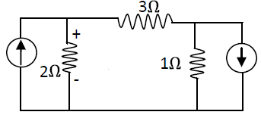 | L3 | CO2 | [2M]
3 | Derive the equation for self inductance. | L4 | CO3 | [2M]
4 | Define the terms Active power, and Reactive power. | L1 | CO4 | [2M]
5 | Explain the term Quality factor of a circuit in resonance. | L2 | CO5 | [2M]
6 | State the Norton’s Theorem. | L1 | CO6 | [2M]
7 | Derive an expression of the energy stored in an inductor. | L4 | CO1 | [2M]
8 | Why an impedance represented by a complex number? How is complex impedance dependent on frequency? | L2 | CO3 | [2M]
9 | Mention some salient features of Reciprocity theorem. | L1 | CO6 | [2M]
10 | Write about the effects of leakage factor in a magnetic circuit. | L1 | CO4 | [2M]

Part – B Max.Marks:50
ANSWER ANY FIVE QUESTIONS. EACH QUESTION CARRIES 10 MARKS.

 |  |  | BCLL | CO(s) | Marks
11. | a) | Explain the principle of Duality with an example. | L2 | CO1 | [5M]
 | b) | In the following network determine 10Ω resistor across voltage.  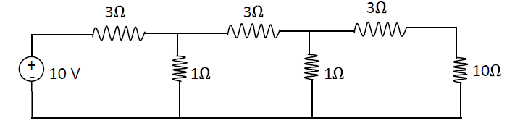 | L5 | CO1 | [5M]
12. |  | For the circuit shown figure construct a tree in which 10ohms and 20 ohms are in tree branches. Using nodal analysis.  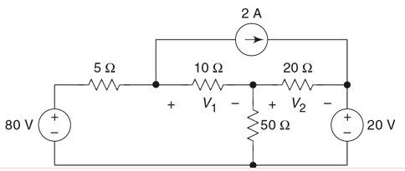 | L5 | CO2 | [10M]
13. | a) | Comparison between electric and magnetic circuits (Any four points) | L4 | CO3 | [5M]
 | b) | Explain the Faraday’s law of electromagnetic induction and list its applications. | L2 | CO3 | [5M]
14. |  | Explain about the steady state analysis of resistance in parallel combination with sinusoidal excitation. | L2 | CO4 | [10M]
15. | a) | List the different properties of series and parallel resonant circuits. | L1 | CO5 | [5M]
 | b) | Define and explain short circuit parameters by taking one example. | L2 | CO5 | [5M]
16. | a) | In the circuit shown, what value of R_{L} (in W) maximizes the power delivered to R_{L}?  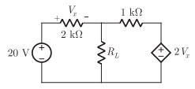 | L5 | CO6 | [5M]
 | b) | In the given network, if Is = I₀ then V = 1 volt. What is the value of I1 (in Amp) if Is = 2 I₀?  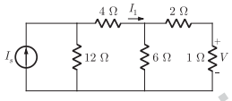 | L5 | CO6 | [5M]
17. | a) | Derive the relations of resistances in star-to-delta transformation. | L4 | CO1 | [5M]
 | b) | Derive the equation for Equivalent inductance, when two inductors are coupled in series opposing and mutual inductance exists between them. | L4 | CO2 | [5M]
18. | a) | List the different properties of Series and Parallel resonant circuits. | L1 | CO4 | [5M]
 | b) | A voltage source V=Vm sin wt is applied to a series R-L circuit. Determine the expression for average power consumed. | L5 | CO5 | [5M]

-- 00 -- 00 –

